CLASSIFICATION ALGORITHMS
USE INDEX AS UID MOD 2
INDEX 0: NAÏVE BAYES
INDEX 1: DECISION TREE
EVERY ONE WILL DO SUPPORT VECTOR MACHINE ALGORITHM USING PYTHON LIBRARIES
SELECT ANY DATASET OF YOUR CHOICE
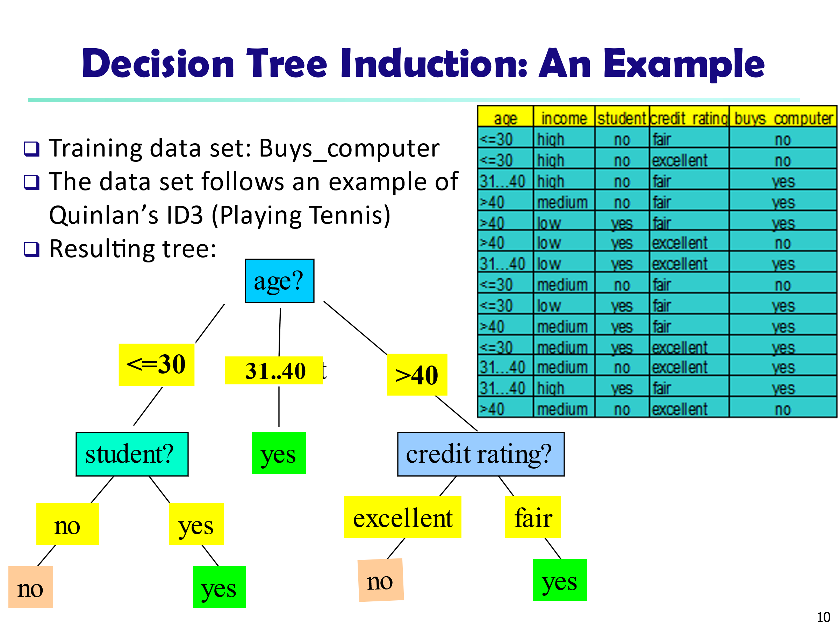
Data to be classified:
X = (age <=30,
Income = medium,
Student = yes
Credit_rating = Fair)

